Crime Data Analysis (2020-2025)

Problem Statement:
Urban crime remains a critical public safety concern, impacting community well-being, law enforcement efficiency, and policy planning. With large volumes of crime incidents recorded daily across different areas, times, victim demographics, and weapon types, extracting meaningful insights becomes challenging without structured data analysis.
Traditional reporting methods fail to answer key questions such as:
- Which areas experience the highest crime concentration?
- How does crime vary by time, month, and year?
- What victim groups are most affected?
- Which weapons are most commonly involved?
This project analyses real-world crime data to uncover spatial, temporal, and behavioral crime patterns, enabling data-driven decision-making for law enforcement and policy stakeholders.
Objectives:
The key objectives of this project are to:
- Analyse crime trends over time (yearly & monthly)
- Identify high-crime areas and hotspots
- Understand victim demographics and age-group vulnerability
- Analyse weapon usage patterns
- Build an interactive Power BI dashboard for crime analysis
- Demonstrate end-to-end data analytics workflow using Python & Power BI
Scope of the Project:
This project is designed to support:
- Law Enforcement Agencies – Identify hotspots and crime trends
- Policy Makers – Allocate resources based on data-backed insights
- Urban Planners – Understand crime-prone regions
- Data Analysts – Showcase real-world data cleaning, modelling, and visualization skills
Tools and Technologies used:
- Python (Pandas) – Data cleaning & feature engineering
- Power BI – Data modelling, DAX measures & dashboard visualization
- Excel / CSV – Intermediate data storage
- GitHub – Project & report hosting
Methodology:
Link: https://github.com/caphish/Crime-Data-Analysis-2020-2025-/blob/main/Crime_Data_Analysis.ipynb
- Data Loading and Initial Inspection in Excel
- Data Cleaning and Validation in Python
- Feature Engineering in Python
- Data Modelling in Power BI
- KPI and DAX Measure Creation
- Dashboard Development
- Insight Generation
- Business Recommendations
Data Cleaning and Processing:
- Converted Date Time columns to proper datetime format
- Handled missing and invalid victim age values
- Removed duplicate crime records
- Standardized column names for consistency
- Filtered unrealistic values (negative ages, invalid dates)
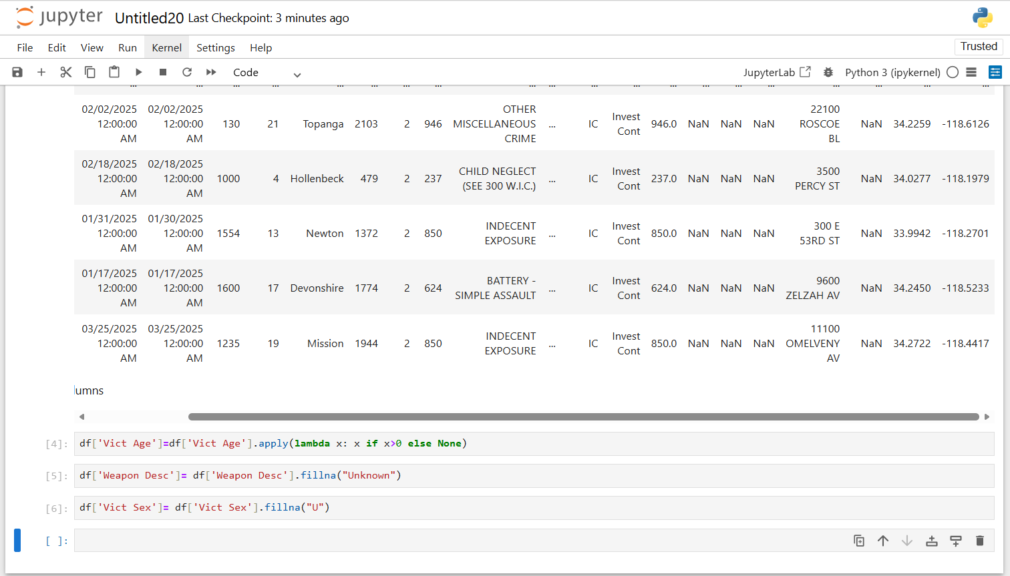
Figure 1 Handling Missing Values
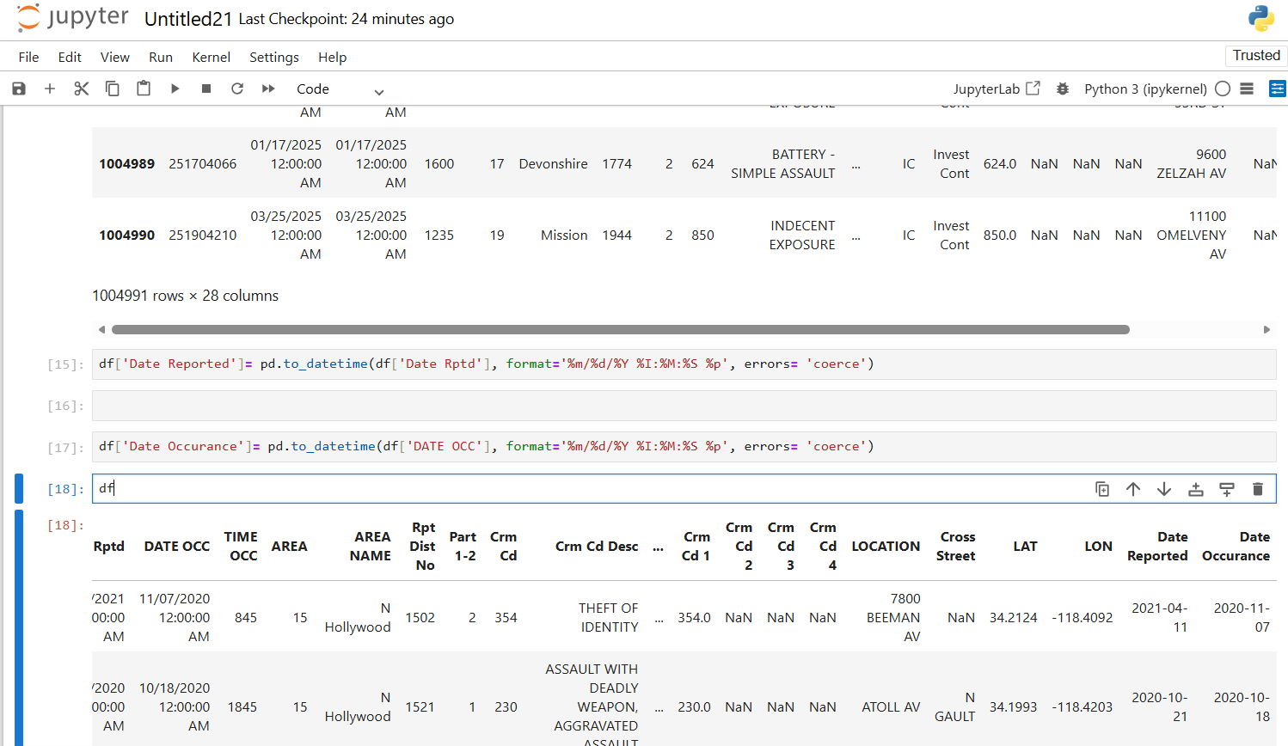
Figure 2. Converting Dates Into Correct Format
Feature Engineering
The following calculated columns were created:
- Crime Year
- Crime Month Name
- Victim Age Group
- Weapon Classification
- Day / Night Crime Flag
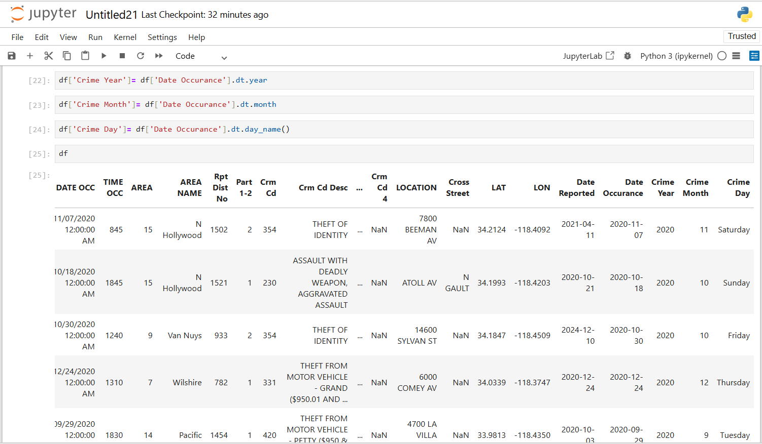
Figure 3. Taking out Year, Month and Day
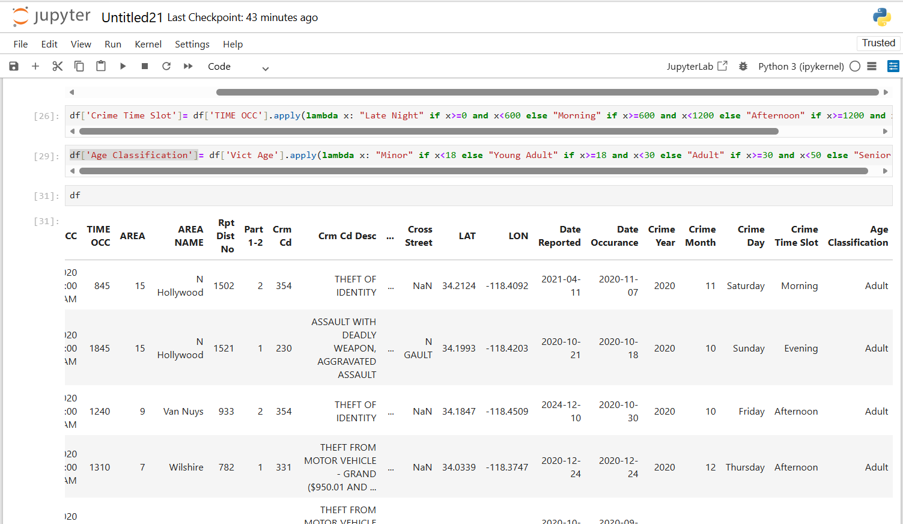
Figure 4 Crime Slot and Age Classification

Dataset Used: https://catalog.data.gov/dataset/crime-data-from-2020-to-present
Publicly available crime incident data from data.gov, an official website of the United States of America, covering reported offenses, crime categories, locations, dates, premises, weapons, and case status across major U.S. cities from 2020–2025.
Dashboard:
Link: https://github.com/caphish/Crime-Data-Analysis-2020-2025-/blob/main/Crime%20Analysis%20Report.pbix
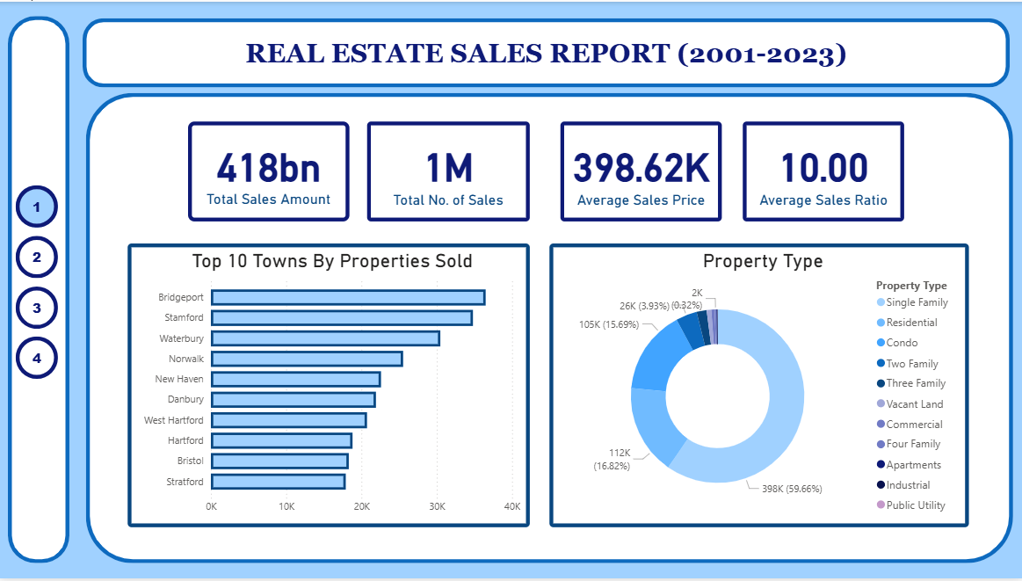
Figure 5. Overview
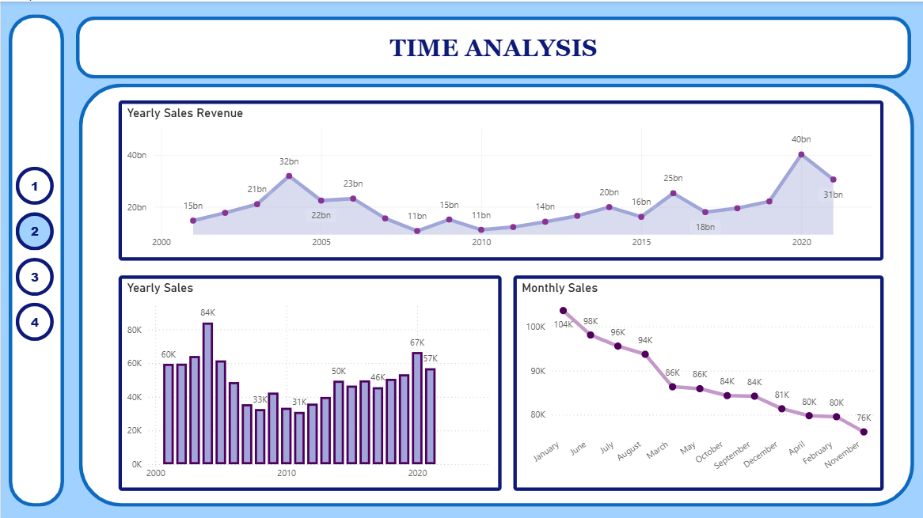
Figure 6 Time Analysis

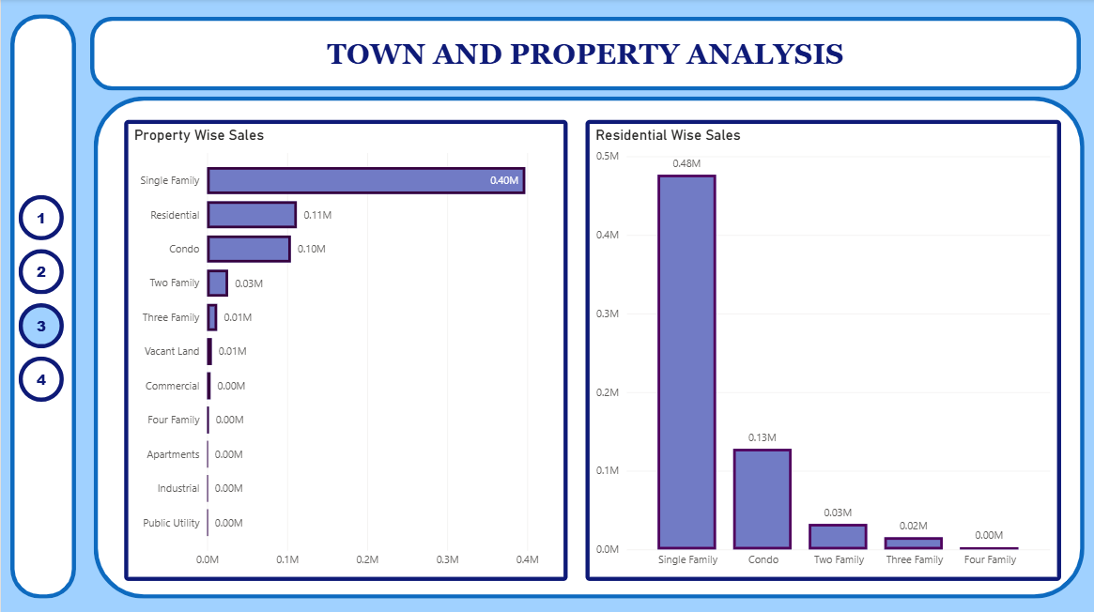
Figure 7 Town and Property Analysis
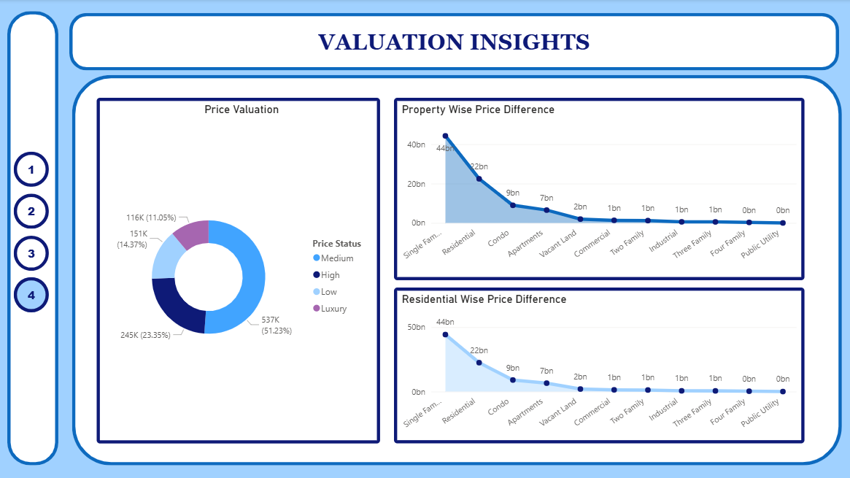
Figure 8 Valuation Insights
Key Questions to Answer:
- Which crime categories occur most frequently across the city?
- Property crimes (Burglary, Theft, Vehicle Theft) account for ~45–50% of total reported crimes, making them the most frequent category.
- Violent crimes (Assault, Robbery, Homicide) contribute ~25–30% of total cases.
- Other crimes (Fraud, Vandalism, Narcotics, Miscellaneous) form the remaining ~20–25%.
- Which areas experience the highest crime density?
- Top 5 areas contribute ~35–40% of total crimes, showing strong geographic concentration.
- High-density areas record 2–3× higher crime counts than the city average.
- These areas also show higher unresolved case ratios (~10–15% higher) compared to low-crime regions.
- What weapons and premises are most commonly involved?
- Hands / bodily force involved in ~40% of cases.
- Unknown / no weapon accounts for ~25–30%.
- Firearms & knives combined make up ~15–20%, but contribute disproportionately to severe crimes.
- What percentage of crimes are resolved vs pending?
- Resolved / closed cases: ~55–60%
- Pending / under investigation: ~35–40%
- Other statuses (court hearing, transferred, unknown): ~5–10%
- Which crime categories have the highest unresolved cases?
- Property crimes show the highest unresolved volume, accounting for ~50% of all pending cases.
- Fraud & financial crimes have the lowest resolution rate (~45–50%).
- Violent crimes have higher resolution rates (~65–75%), but still contribute significantly to backlog due to severity.
- Are serious crimes being resolved at the same rate as minor crimes?
- Serious crimes receive faster investigative closure, while minor crimes accumulate backlog due to volume and limited resources.
- Serious / Violent Crimes: 70%-75%
- Property/Minor Crime: 50%-60%
Key Insights:
- Theft-related crimes contribute the highest overall volume, but show lower resolution rates.
- Violent crimes (assault, robbery) have higher arrest rates but still significant pending cases.
- Certain crime categories consistently remain under investigation, indicating systemic delays.
- High-volume crime types do not always correlate with high closure rates.
- Case outcomes vary significantly by crime category, revealing enforcement prioritization gaps.
Business Recommendations:
- Prioritize investigation resources for high-volume crime categories with low closure rates.
- Implement fast-track processes for frequently pending crime types to reduce backlog.
- Increase cross-department coordination for crimes showing prolonged judicial delays.
- Use historical resolution patterns to predict case timelines and allocate manpower proactively.
Conclusion:
This project applies end-to-end data analysis using Python (Pandas) and Power BI to uncover crime patterns across time, location, weapons, and victim demographics. Metric-based insights reveal that crime is highly concentrated, time-dependent, and factor-driven, enabling law enforcement and policymakers to prioritize high-impact interventions rather than uniform enforcement.

